Title (Arial, 12 pt, bold, centered)

A. Firstauthor¹, B. Secondauthor^{1,2}, C. Thirdauthor² (Arial, 11 pt, centered)

¹ Institution1 (Arial, 11 pt, centered)

² Institution2 (Arial, 11 pt, centered)

The abstract begins here. It will be included in an abstract booklet. It must not be longer than 1 page including tables, figures, and references!

Text must be in Arial, 10 pt, justify. Page size is DIN A4 (210 x 297 mm); 25 mm margins left, right and top; 20 mm bottom margin; line spacing single spacing.

Title, authors, and institutions as shown above. The presenting author must be underlined. Note that the presenting author does not necessarily need to be the first author! In case of a single author and/or a single institution, numbering of institutions is not required.

References should be numbered and placed in square brackets like, e.g., [1]. If the reference contains more than two authors list only the first one followed by “ et al.,” [2].The references should be listed at the end of the text according to the example shown below. Note that no titles are required for cited papers, only for books [3] or edited books [4].

Figures as for example Fig. 1 and tables should be placed below the references. The caption should be in Arial 11 pt, justify (see below).

The template is provided in different formats (*.doc, *.docx, *.rtf, and *.odt). Use the format that suits you most. After finishing the preparation of your abstract, save your abstract in PDF format with a file name that includes the name of the presenting author. For example, if the presenting author is Bob Miller, then save the abstract under Miller_Bob.pdf. In case, the same presenter submits two abstracts, he should give them also a number (e.g. Miller_Bob_1.pdf and Miller_Bob_2.pdf). The Abstract can be uploaded on the conference web site only in PDF format (see https://www.tu-chemnitz.de/physik/TEPH/ISEG2026/index.php).

References:
[1] A. Author and B. Anotherauthor, Phys. Rev. B 666 (2014) 125500.
[2] A. Author et al., Phys. Rev. Lett 123 (2000) 111658.
[3] A. Author and B. Anotherauthor, The Name Of The Book (Publisher, City, Year published), p. pages used.
[4] A. Author et al., in The Name Of The Edited Book, edited by E. Editor and F. Anothereditor (Publisher, City, Year published), p. start page of chapter.

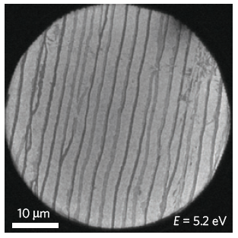
Fig. 1: This is the figure caption. This is the figure caption. This is the figure caption. This is the figure caption. This is the figure caption.

