A Report on SYSU&TUC Exchange Program
Based on personal experiences
This is a thorough description of how a Chinese MA student from the English Department of Sun Yat-sen University thinks about her life and study in Technische Universitaet Chemnitz in Germany.
Admin

Contents

1 Basic Introduction of SYSU&TUC Exchange Program

2 A General Introduction to SYSU and TUC

3 Course Descriptions in SYSU&TUC Exchange Program

4 Experiences of Life, People and Culture in Germany

5 Recommendations on Travel Routes in Europe

6 Reflections and Suggestions

1 Basic Introduction of SYSU&TUC Exchange Program

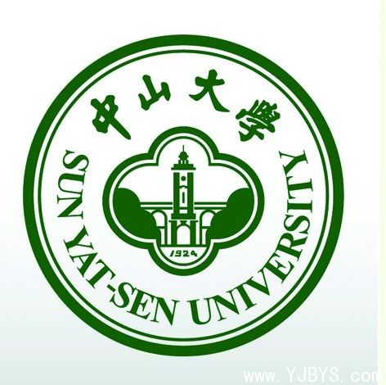
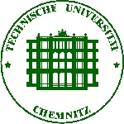

Background: Sun Yat-sen University and Chemnitz University of Technology are both renowned universities in their own countries, and they seized the great opportunity to collaborate with each other when Prof. Schmied and Prof. Chang first met in 2013 during the 18th Conference of the International Association for World Englishes (IAWE).

Purposes: The main purpose of the exchange program between SYSU and TUC is to embrace internalization and nurture students from both universities as global citizens with international perspective as well as local root throughout their studies abroad. To be more specific, students from both universities can collaborate on academic levels to collect data for their MA theses, can travel through Europe or Asia to get first-hand evidence of how people live their lives, how this part of the world looks like, how people view things according to their beliefs, and also can also make friends with people from all over the world, and through international friendship can they become more open-minded persons. Besides, it is said that having experience in different countries will change the track of students’ lives completely.

Duration:

Participants:

Study Plan:
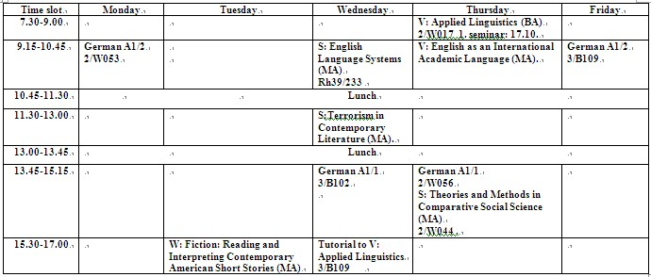
Course Requirements:
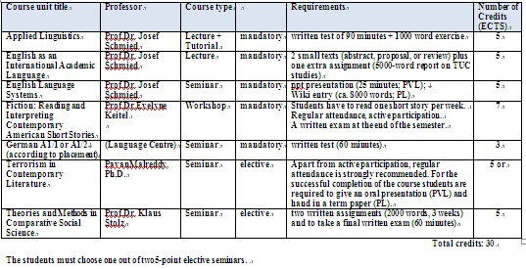
For more details about the exchange program between SYSU and TUC see the website below:
http://www.tu-chemnitz.de/phil/english/ling/SYSU_2013.php

2 A General Introduction of SYSU and TUC
Sun Yat-sen University (SYSU)
Sun Yat-sen University, also known as Guangdong University originally, was founded in 1924 by Dr. Sun Yat-sen (also called Zhongshan), who was one of the most renowned historical figures in Chinese history, and who dedicated his whole life to achieve democracy and unity in China.

SYSU is located in Guangzhou, which is the third biggest city in China and the forefront of China’s Reform and Opening up policy. “Being one of the leading universities in the People's Republic of China, Sun Yat-sen University is a comprehensive multi-disciplinary university, including the humanities, social sciences, natural sciences, technical sciences, medical sciences, pharmacology, and management science. At present, Sun Yat-sen University covers a total area of 6.17 square kilometers and has 4 campuses: Guangzhou South Campus, Guangzhou North Campus, Guangzhou East Campus, and Zhuhai Campus.

Beautiful Campus
The Guangzhou South Campus
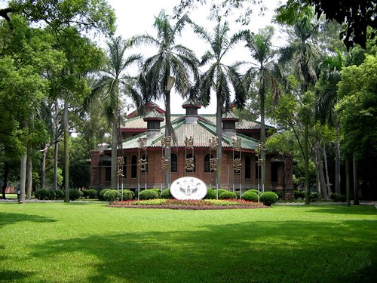
Situated on the southern bank of the Pearl River, the Guangzhou South Campus (the main campus and it is the former Sun Yat-sen University) covers an area of 1.17 square kilometers. In the central area, there are many old buildings of red bricks and green tiles in delighted contrast with new modern ones. With its green lawns, tall trees, bamboo groves, and other lush subtropical vegetation, the campus offers a quiet and pleasant environment for learning and research. On this campus, there are postgraduates of liberal arts and sciences and parts of senior undergraduates working for their degrees and the Chinese learners from overseas.

The Guangzhou North Campus
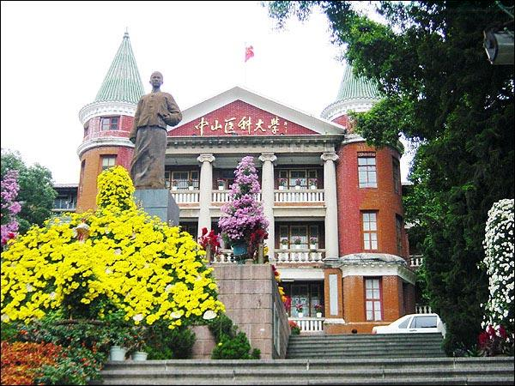
Situated in downtown of Guangzhou, the Guangzhou North Campus (the campus of former Sun Yat-sen University of Medical Sciences) has a total area of 0.39 square kilometers. In 1886, Dr. Sun Yat-sen studied medicine and undertook revolutionary activities here. On this campus, there are postgraduates and senior undergraduates for medical sciences working for their degrees. Zhongshan School of Medicine originated from former "South China Medical College" which had a history of more than 140 years and was the first medical school practising western medicine in China.

The Zhuhai Campus
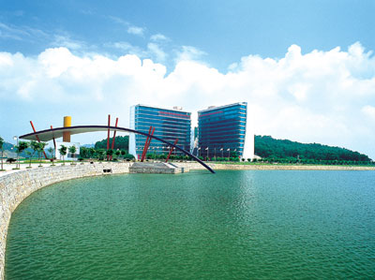
Situated in Tangjia Wan (Tangjia Bay), Zhuhai City, the Zhuhai Campus covers a total area of 3.428 square kilometers, about 120 kilometers away from Guangzhou. With three sides surrounded by the hills and one side facing the sea, the campus enjoys a beautiful landscape and fresh air. Parts of undergraduates (from the 1st year to 4th year students) and parts of the 1st year and the 2nd year’s undergraduates are arranged to study on this campus.

The Guangzhou East Campus
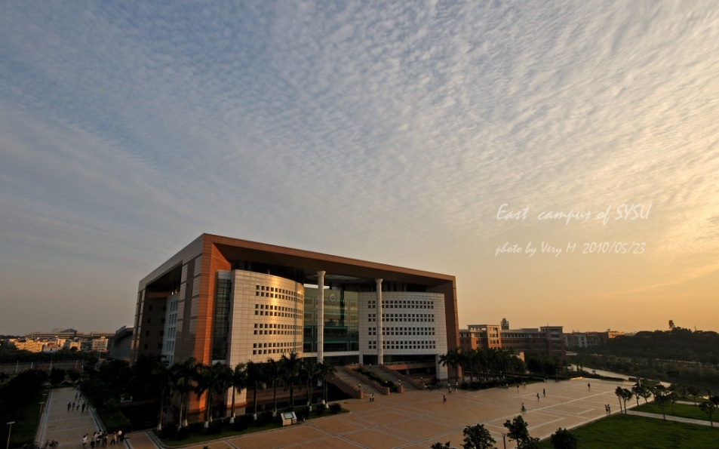
Located in Guangzhou University Town in Xiaoguwei, Panyu, where ten universities have their new campuses including Sun Yat-sen University, the Guangzhou East Campus covers an area of 1.13 square kilometers. It was opened from September, 2004. Parts of undergraduates (from the 1st year to the 4th year students) and parts of 1st year and the 2nd year undergraduates are arranged to study on this campus.

Good Facilities
The University boasts excellent facilities and offers satisfactory services. There are special international student dormitory buildings on the Guangzhou South Campus and the Guangzhou North Campus. At present, the international students studying on the Guangzhou East Campus and the Zhuhai Campus have to live in the same dormitory buildings with the Chinese students, but they can apply for the independent rooms there.

On each Campus, there are modern sports facilities including a stadium, swimming pools, tennis courts, volleyball grounds, a gymnasium and so on.

The four Campuses all have libraries and computer networks. The University possesses a collection of more than 4,500,000 volumes of books, together with 15,000 kinds of periodicals, and provides on-line international retrieval service.”^{[1]}

Technische Universitaet Chemnitz (TUC)
“Technische Universitaet Chemnitz is located in the town of Chemnitz in Germany. It is officially ranked as 3rd best technical university in Germany. The tradition of science in this region goes back to the 16th century when Georg Agricola (1494-1555), a famous German scholar of minerals, served as the city's mayor. In 1836 the Royal Mercantile College was established as a scientific base to support the industrial revolution. In 1882 more than 1,000 students registered for this college. Modern scientific areas like electrical engineering were included in the curriculum. These developments made it possible for the institution to become a Royal Technical Academy ("Königliche Gewerbeakademie"). This academy played a major role in helping Chemnitz to become one of the industrial centers at the beginning of the 20th century. At this time Chemnitz had the highest number of patent registrations in the whole of Germany and hence also in the whole world.”^{[2]}

Campuses
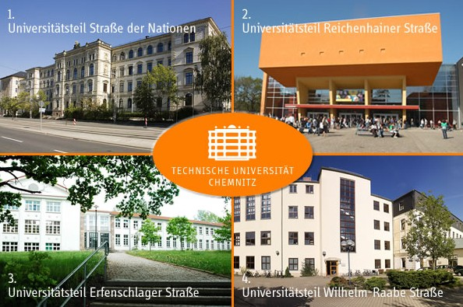
TUC has mainly four campuses, but as MA exchange students, we mainly study in Reichenhainer Strasse.
For more info about TUC campuses see below: http://www.tu-chemnitz.de/tu/lageplan/campusfinder/index.php

3 Course Descriptions in SYSU&TUC Exchange Program
As mentioned earlier in this report, there’re mainly seven courses for SYSU exchange students to choose, and they are: Applied Linguistics, English as an International Academic Language, English Language Systems, Fiction: Reading and Interpreting Contemporary American Short Stories, German, Terrorism in Contemporary Literature, and Theories and Methods in Comparative Social Science. Here, I will give a basic introduction of the teachers first, and then introduce their courses thoroughly, so that the teaching styles of German professors can be seen.

At first, it is necessary to have some general knowledge on the classification of German university courses. Basically, from what I have been through, courses are divided into seminars, tutorials, and lectures according to the number of students and ways of teaching. Usually, seminars and tutorials are more participative and require students’ discussion and academic debate between each other. Normally, seminars are attended by a small group of students between 10 and 20 and are led by a tutor or lecturer. Students are expected to have researched the subject in advance so as to contribute to the academic debate in class. Similar to seminars, tutorials are attended by a smaller group of people, and students are required to prepare for the discussion in tutorials, for they should play an active role in class and challenge the tutor with ideas and questions. Generally, lectures are presented by professors. Although students may have the opportunity to ask questions at the end of lectures, professors usually do all the talking.

Professors

“Josef Schmied has held the Chair of English Language & Linguistics at Chemnitz University of Technology since April 1993. He completed his PhD on English in Tanzania" in 1984 and his postdoctoral thesis on relative constructions in British and Indian English (LOB and Kholapur Corpus) in 1991. His main research interests are in Language & Culture (sociolinguistics, English in Africa and SE Asia, Academic English) and in Language & Computers (corpus-linguistics, e-learning, www English and Wiki+). He has been active in the ICE (International Corpus of English) network and in ESSE (European Society for the Study of English) with a seminar on "Empirical Approaches to Discipline, Culture and Identity in Academic Discourse" in Torino in August 2010 and a new proposal for the “Rhetoric of Science” in Istanbul in 2012.”^{[3]}
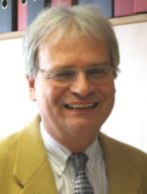

Prof. Dr. Josef Schmied

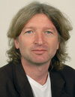
Klaus Stolz received his MA degree in Freiburg University and got promoted in 1997 until he received habilitation in Göttingen University in 2007. Now he’s Professor of British and American Studies in TU Chemnitz.
Check the link below more info:
http://www.tu-chemnitz.de/phil/english/chairs/cultstud/persons_stolz.php

Prof. Dr. Klaus Stolz

The above are professors, whose courses I have attended. Apart from them, there are also courses taught by doctors and a tutorial led by an MA student.

Seminars in this exchange program
English Language Systems
This seminar is organized by Prof. Schmied in the first few courses. He always challenges students on certain concepts related to English language. For example, he asked students to define relative pronouns and think about possible paradigms of relative clauses. Later he asked students to give presentations on subjects, which they are interested in, so that students can discuss between themselves to reach agreements on concepts of specific terms. Up to now, students take turns to hold this seminar and Prof. Schmied aids the lecturer to challenge participating students. In order to survive this seminar, my suggestion is: first of all, be knowledgeable in your interested area; second, be supportive and actively participate in class debate; third, be prepared when it’s your turn to lead this seminar, for example, make a PowerPoint for fellow students and print out handouts as guidance.

Fiction: Reading and Interpreting Contemporary American Short Stories
Prof. Keitel is responsible for this seminar. She always leads this seminar by herself, and asks the same questions: what’s your spontaneous reaction to this story? What makes this story special? Let’s discuss the content of this story, etc. Although it’s interesting to discuss features of American short stories during class, and I can see Miss Keitel is a very knowledgeable professor, I still cannot get the point of doing this seminar, and what achievements students can have after this course? But one thing is certain: if you prepare and deliver answers for all the prototypical questions she is going to ask, you can survive her seminar.

Theories and Methods in Comparative Social Science
This seminar is held by Prof. Stolz, who is a very caring and open-minded teacher. Unlike Prof. Schmied’s way of teaching, it is always he who leads this seminar. Before attending this seminar, students should always prepare for the topic that is going to be discussed during class. For example, students should read articles on social research, nationalism, globalization and qualitative, quantitative and comparative research. In order to actively participate in in-class discussion, students should also have a broad knowledge on politics of the world, to be more specific, politics of Europe and America.

Lectures
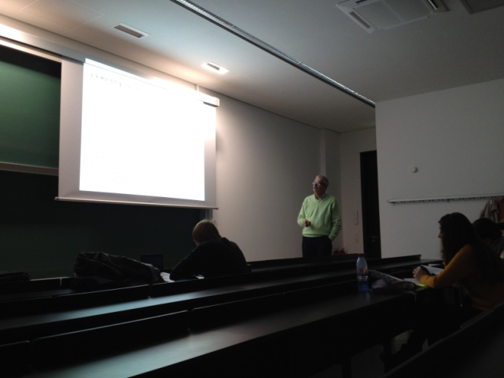
There are only two lectures for SYSU exchange students and they are Applied Linguistics and English as an International Academic Language, both delivered by Prof. Schmied. In the first lecture, Prof. Schmied talks about basic definitions in the field of applied linguistics, which, from my point of view, is kind of reviewing what SYSU exchange students have learnt. The second lecture is more interesting, for the tasks after class really involve students to do something. Up to now, we have finished a book review and a report.
Prof. Schmied in his lecture

Tutorial
This tutorial is given by a MA student whose name is Tobias Roehner. This tutorial serves as a backup for Prof. Schmied’s lecture Applied Linguistics. What happens in this tutorial is that Tobias will prepare for some handouts for students to discuss in the class and if problems from students cannot be solved during class, he will ask Prof. Schmied in his next lecture.

From the above, one can have a basic impression on a German University’s way of teaching, that is, let students learn by themselves in discussion, and teachers usually only offer guidance. I can see there are advantages and disadvantages in this way of teaching. The good thing is that students’ imagination and creativity are not constrained by fixed rules or answers, and they may have very good ability to manage things by themselves. The bad thing is that if teachers let students go too far without any guidance on what type of books they should read, students will end up with having an unorganized knowledge structure and only know the small parts they have read.

As an exchange student myself, I have to say I have struggled all my way to get German professors’ expectations on students. At first, Prof. Keitel always complains about Chinese students’ behavior in class. Others might wonder why Chinese students are so stupid and just sit there without talking. What they don’t know is that most courses in Chinese universities are delivered in lecture forms, and students are not necessarily to participate in class, for teachers are always the ones who tell them what materials they should read or what tasks they should accomplish. So here I have a possible suggestion for Prof. Schmied: explain the differences between seminars and lectures to the next group of exchange students in advance, so that they have more preparation to participate in discussions and debates in class and not fail teachers’ expectations.

4 Experiences of Life, People and Culture in Germany
The exchange program between SYSU and TUC provides Chinese students with a good opportunity to experience life and culture in Germany and Europe, which will definitely change their lives, expand their horizon, and help their careers in certain ways.
Life in Chemnitz
Chemnitz is the city where we live. It is considered as the third largest city in Saxony after Leipzig and Dresden, and it has a population of 241,210 by 2012 and a total area of 220.85 km². The main transportation system in Chemnitz includes buses, trams and trains. Below is a map of tram and bus network in Chemnitz:
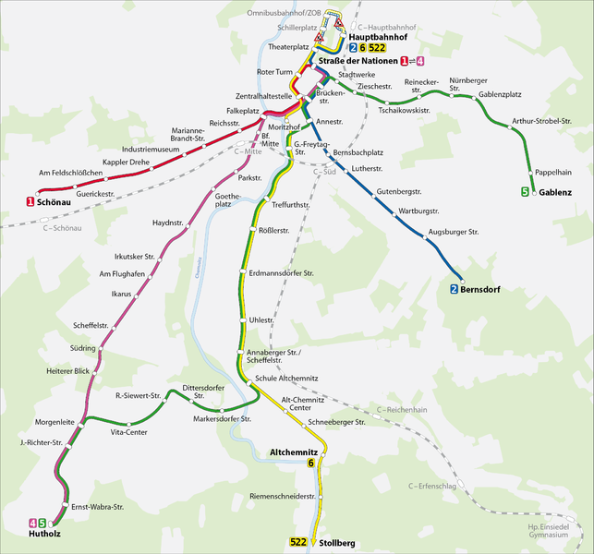
This is the centeral disctrict of Chemnitz, where students can find large shopping malls, drug stores (Apotheke), and shops like ROSSMAN, Tedi and Woolwirth to buy necessities of living. (Take Tram2 and get off at Zentralhaltestelle)

Take Tram2 from Chemnitz train station and get off at either Wartburg Str. or Augsburg Str., students can easily find their dorms on Vetter Str.
This is where the main campus lies on Reichenhainer Str.

Map of bus and tram in Chemnitz
If Chinese exchange students want to get to Chemnitz, the cheapest way is to buy a ticket from Guangzhou to Berlin and then take a bus to Chemnitz. Good news about being a student of TUC is that with a student ID card in hand, students can travel through Chemnitz by bus or by tram without paying any fees. What’s more, this bonus expands to travel in whole Saxony by train. Therefore, one may guess how much money he can save if he travels a lot by train.

Having a basic idea of the transportation system in Chemnitz, it’s time to move on to food in Chemnitz. At first, I was quite shocked by how much meat, bread and super sweet cakes and cookies Germans eat. There’re many bread shops in Chemnitz for Germans’ typical breakfast is bread with butter, or marmalade or salamis or cheese and so on. Here is a picture for breakfast taken during Christmas holiday in one of my German friend’s house:
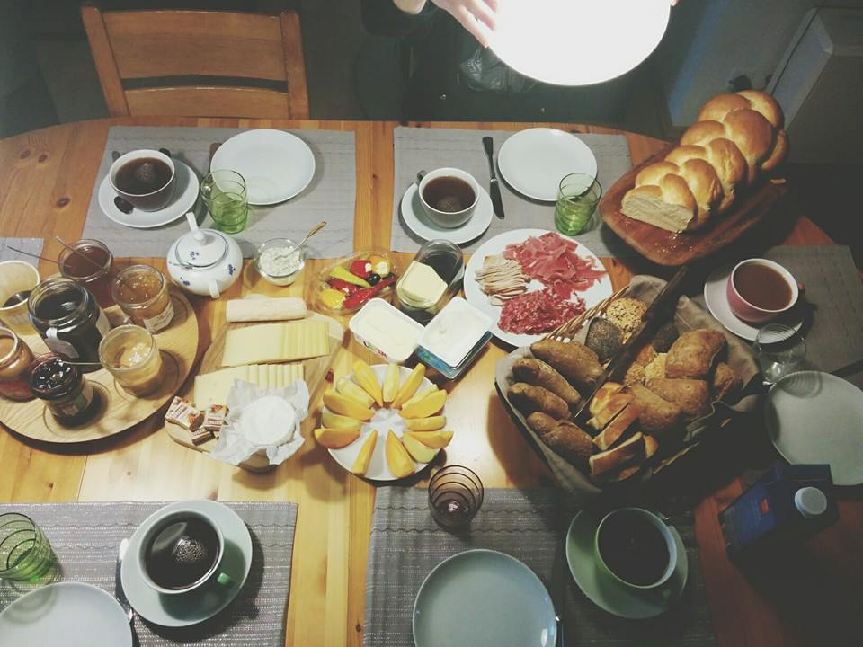
Breakfast during Christmas Time

As to lunch or dinner, as far as I know, Germans eat all kinds of European food, such as spaghetti, coq au vin, Kaesspaetzle, Swedish meat balls and so on. Germans also like to eat all kinds of sausages, and if one goes to Edika or Kaufland or other supermarkets, he can see shelves piled with different kinds of sausages. As for me, I can try some German food from time to time, but my favorite is always Chinese food. Luckily I get a kitchen in my dormitory and my longingness for Chinese food keeps me practicing Chinese cooking. Therefore, I can make delicious Chinese dishes such as bouilli, sweet and sour eggplant, Kung Bao Chicken, bone soup and so on.
People
Long before I went to Germany, I had this stereotype about German people: Germans are always punctual; Germans are very serious; Germans change clothes every day; Germans wear perfume otherwise they stink, etc. Now since I’m in Germany, I find that these stereotypes are not totally true. Being punctual is a really good character, but Germans are not always punctual for when my German buddy and one of my other German friends made appointments with me, they often change their plans in the last few minutes, simply because they cannot make it on time. As for putting on serious faces, I find Germans that I met are quite friendly and helpful, and they smile when you smile at them too. With respect to changing clothes every day, this is definitely not true especially with students and professors. Therefore, Chinese students don’t have to tuck their luggage boxes to the extreme of explosion to bring as many clothes as possible to Germany. Here one thing can be added as tips for Chinese students, that is, bring dark color clothes to Germany if they can, for German people usually wear dark clothes when they reach eighteen to show adulthood. As for the stinky aspect of Germans, I haven’t had a whiff on anyone, thus I cannot tell.

As to Germans’ social interactions, form what I have known, Germans like to go to parties to meet new people or know others via friends. This has something to do with the fact that Germany has a small population compared to that of China, so it is not easy for them to just come across a stranger in street and start talking. One thing Chinese students need to bear in mind is that if a German boy visited you frequently, he might be into you.

Here Germans’ stereotypes on Chinese can also be discussed. Some Germans think Chinese people constrain to themselves and are not willing to talk or get close to local people; Chinese people are rude when they start eating for they might make loud sounds during eating; Chinese people like to give presents to them, and by doing so they might want something from them; Chinese are good at math, etc. Therefore, when Chinese exchange students want to make friends with German students, what they have to do is to be brave enough to start a conversation first, and eat quietly when invited by German friends, and explain to them that Chinese just want to show kindness when they give them souvenirs.

Culture
Life and people are aspects of culture, what I also want to add here, however, are two festivals in Germany. The first festival is Oktoberfest (Beer Festival), which is a renowned festival in Bavaria in Germany. “It is a 16-day festival running from late September to the first weekend in October with more than 6 million people from around the world attending the event every year. Only beer conforming to the Reinheitsgebot, at a minimum of 13.5% Stammwürze (approximately 6% alcohol by volume) may be served at Oktoberfest. The beer must also be brewed within the city limits of Munich. Beers meeting these criteria may be designated Oktoberfest Beer.” During this festival, locals show up sporting the traditional Bavarian costume: frilly dresses with plenty of cleavage called dirndls for the ladies, and leather pants with suspenders called lederhosen for the guys.
For more information about Oktoberfest see: http://en.wikipedia.org/wiki/Oktoberfest
Oktoberfest Dress: http://howto.wired.com/wiki/Dress_for_Oktoberfest

The second festival we have experienced in Germany is Christmas holiday. For Germans, Christmas holiday is the most important festival of a year, which lasts from 21st of December to 5th of January. Usually, almost a month before Christmas, each city opens at least a Christmas market, where different kinds of snacks are sold, several entertainment devices are operated, and Gluewein and Kinderpunsch (special drinks offered in Christmas markets) are drunk. Below are some pictures of Christmas markets in different cities:

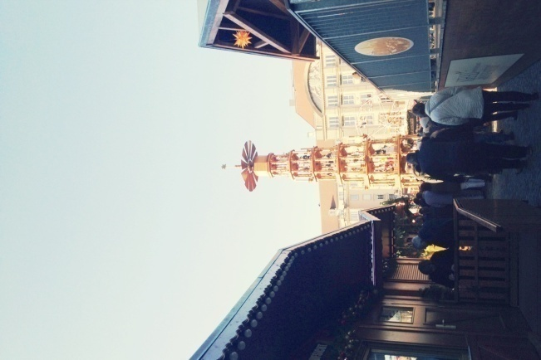

Christmas market in Leipzig
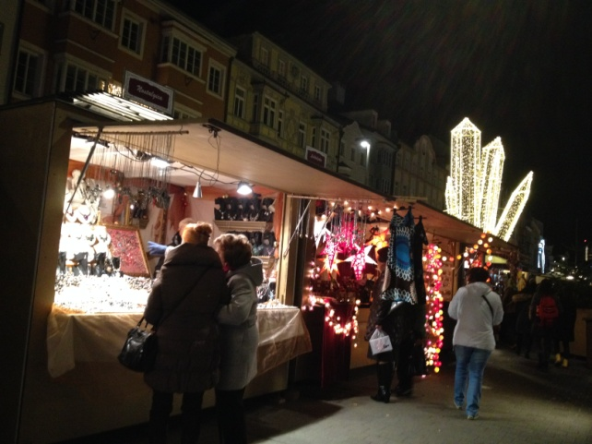
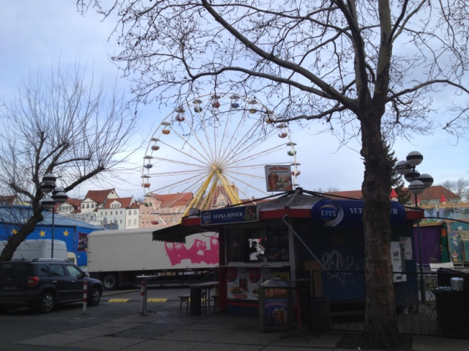

Christmas market in Innsbruck
Christmas market in Jena

I was luckily invited to a German friend’s home, and his family’s breakfast has been shown above. From what I know, Germans usually put Christmas tree at the corner of the room instead of in the middle of the room. Below are my friend’s Christmas tree at home and how his family’s living room looks like. The difference between living rooms in China and Germany is quite obvious: a Chinese living room has a TV set in the front of a living room while a German living room has tables and chairs and musical instruments, etc. It seems that for Chinese watching TV is quite a common way to kill time while for Germans reading and chatting.
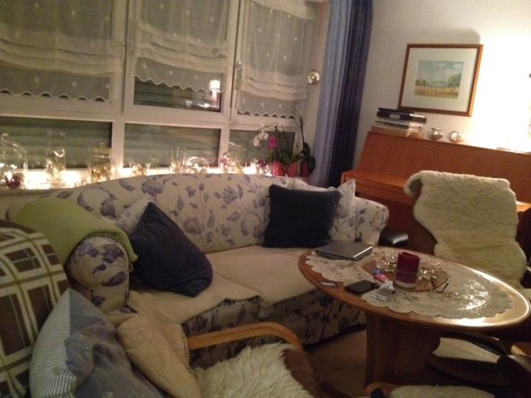

<fig>

Christmas tree and me
Lovely living room

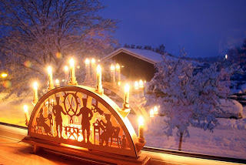
Here one phenomenon I found interesting during Christmas is that people in Saxony usually put a special kind of lights on their windowsills, and this kind of lights is called Schwibbogen in German language. “The decoration originates from the Erzgebirge, a mountain range in Southern Saxony. The area was once famed for its bronze mining industry and the decoration was created to represent the men who mined the ore, never seeing daylight during winter months. The arch is said to represent the mouth of a tunnel and the candles, light. Originally made during the 18th century, using iron, today they are made of wood and often have electric lights, rather than real candles.Large ones are displayed at Christmas markets around Germany and are as commonplace as the Christmas Tree. Some also depict Christian, or seasonal scenes.” ^{[4]}

5 Recommendations on Travel Routes in Europe
There is a Chinese saying that travelling is more eye-opening than reading. Therefore, when given a chance to explore Europe, one should take it! Here are some of the European countries and cities I recommend Chinese exchange students to visit.

Czech Republic
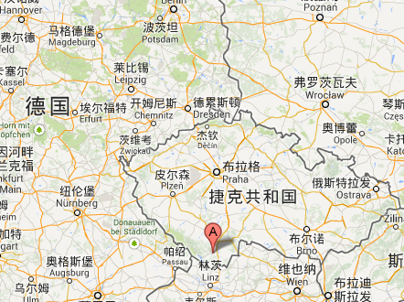

Český Krumlov

Travel route 1
Czech Republic borders Germany, which makes it easy for Chinese students to visit famous tourist sites in Prague. Here I recommend a route starting from Chemnitz to Prague, stay there for one day or two, and then go to Cesky Krumlov, and if time permits, go to Wien in Austria.

In Prague, Charlie’s Bridge and Prague Castle are my favorites. “Charles Bridge is a stone Gothic bridge that connects the Old Town and Lesser Town (Malá Strana). It was actually called the Stone Bridge (Kamenný most) during its first several centuries. Its construction was commissioned by Czech king and Holy Roman Emperor Charles IV and began in 1357. In charge of the construction was architect Petr Parléř whose other works include the St. Vitus Cathedral at the Prague Castle. It is said that egg yolks were mixed into the mortar to strengthen the construction of the bridge.”^{[5]}

If one has read the history of Prague Castle, he can see that it is an endeavor of centuries’ hard work and it looks really amazing.

Cesky Krumlov is a small town in Czech Republic, and it is a UNESCO World Heritage Site. “This charming town experienced its greatest prosperity during the rule of Lords of Rožmberk (1302 - 1602), who chose Český Krumlov to become the seat of their kingdom. At this time, Krumlov lay on the crossroads between the Czech, Austrian, Bavarian and Northern Italian lands. You can see the influence of these different cultures that have left their mark on the town and Castle with brushstrokes of the Italian Renaissance. At the end of 17th century, during the reign of House of Eggenberg, the Castle Baroque Theatre was built and the Castle Gardens were renovated. Under the rule of House of Schwarzenberg, Český Krumlov gained its Baroque appearance. Český Krumlov's Old Town hasn't experienced major changes since the 19th century, other than the demolition of the town's fortification walls and guard towers, and has maintained its historic character.” ^{[6]}

Switzerland
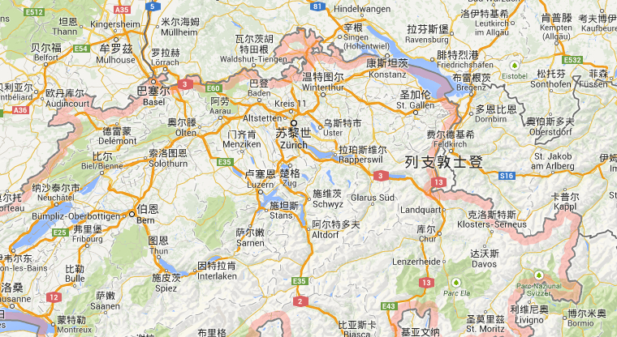

Travel route 2
Switzerland is known by many as a country which has beautiful landscapes, well-educated people, and famous skiing parks. If finance is permitted, it’s highly recommended to go there. Starting from Chemnitz, a highly recommended way of travelling is by train: buy a five-day InterRail Pass for Germany, Switzerland and Austria (this can only be bought at Leipzig or Dresden DB Bahn) and then make a plan for five days. A possible route could be: Fuessen – Konstanz – Lucerne – Interlaken – Berne – Chemnitz.

In Fuessen, one can visit the famous New Swan Castle in Germany. “It was built by King Ludwig II of Bavaria, also known as the ‘Fairytale King’. The Neuschwanstein Castle really looks like a fairytale castle. Neuschwanstein is a castle of the paradox. It was built in the 19th century in Bavaria, in a time when castles no longer had strategical and defensive purposes. While Neuschwanstein's look is that of a medieval castle, it was equiped inside with state of the art technology at that time. For example on every floor of the castle there were toilets with automatic flushing system, as well as an air heating system for the whole castle. Water was supplied by a nearby spring situated at only 200 meters above the castle. Neuschwanstein's positioning is also a fairytale one. It is located in the Alps in Bavaria, Germany, in a magnificent landscape, on the top of a hill. Neuschwanstein overlooks the Hohenschwangau valley.”^{[7]}

In Konstanz, one can visit Boden See. Unluckily, when I reach there, it’s raining all day long, so I haven’t seen much of its beauty. However, the river and houses in Lucerne really took my breath away. It’s the most comforting place that I have been to. The swans and birds swimming in the river gave me a feeling of peace. Interlaken is really suitable place to stay when one wants to go skiing. Skiing equipments can be rented in Grindelwald and coaches for skiing can also be invited there. If one reaches Berne on the fourth Monday of November, he or she can have really enjoyable experience, for that day is Berne’s Onions’ Day. The streets of Berne is filled with venders selling all kinds of onions and dishes, children running after each, and youngsters throwing colorful bits towards each other.

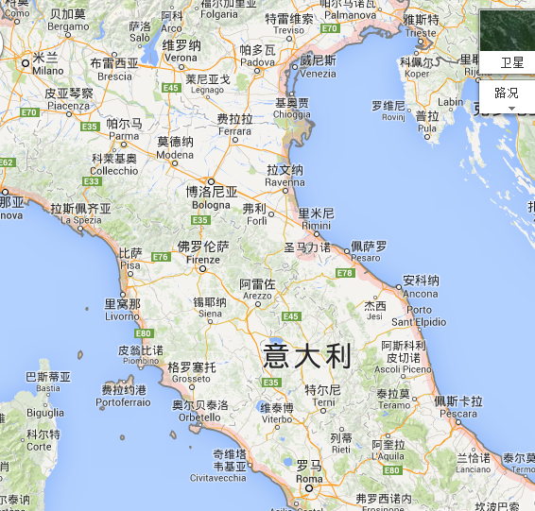
Italy
Travel route 3

Italy is a country with so many fantastic architectures, so one will never get bored there. As it is winter when we get here, a possible recommended route would be: Chemnitz – Venice – Florence – Pisa – Rome – Milano – Chemnitz.

Venice is one of the most interesting and lovely places in the world. “This sanctuary on a lagoon is virtually the same as it was six hundred years ago, which adds to the fascinating character. Venice has decayed since its heyday and is heavily touristed (there are slightly more tourists than residents), but the romantic charm remains. This place may not seem huge but it is. Venice is made of different boroughs. The most famous is the area comprising the 118 islands in the main districts that are called ‘Sestieri’ and they are: Cannaregio, Castello, Dorsoduro, San Polo, Santa Croce and San Marco, where the main monuments and sights are located. Other main districts are Isola Della Giudecca and Lido di Venezia. Other important islands include Murano, Torcello, San Francesco del Deserto, Burano, and several others.” In Venice, Squid Ink noodles are delicious, and gondola riding in the water fields of Venice is also enjoyable, thus they’re highly recommended.”^{[8]}

Florence is the cradle of the Renaissance. “Florence's museums, palaces, and churches house some of the greatest artistic treasures in the world. The most popular and important sites in Florence include the Cathedral, the Baptistery, the Uffizi, the Bargello, and the Accademia. The churches of Santa Maria Novella and Santa Croce are veritable art galleries, and the library of San Lorenzo is a magnificent exhibition of Michelangelo's architectural genius. Wander some of the oldest streets in the city until you reach the Arno River, cross the Ponte Vecchio, and experience the "newest" area of Florence, the Oltrarno. Be sure to set aside time to see the vast and varied art collection housed in the Pitti Palace. It is important to know that Florence's main historic center is relatively small so that it is easy to move around on foot. Using a car around Florence is not advisable, as there is little parking, many streets are pedestrian only and streets are often one-ways. A fleet of small electric buses also provide links between main key areas in the center.”^{[9]}

“The city of Pisa plays host to treasures of priceless value, making it one of Italy's most important cities of art. The Piazza dei Miracoli, with its world-famous Leaning Tower, is the hub of the prized artistic and architectural offerings.”^{[10]}

“Rome (Italian: Roma), the Eternal City, is the capital and largest city of Italy and of the Lazio (Latium) region. It's the famed city of the Roman Empire, the Seven Hills, La Dolce Vita (the sweet life), the Vatican City and Three Coins in the Fountain. Rome, as a millenium-long centre of power, culture (having been the cradle of one of the globe's greatest civilisations ever) and religion, has exerted a huge influence over the world in its circa 2800 years of existence.
The historic centre of the city is a UNESCO World Heritage Site. With wonderful palaces, millenium-old churches and basilicas, grand romantic ruins, opulent monuments, ornate statues and graceful fountains, Rome has an immensely rich historical heritage and cosmopolitan atmosphere, making it one of Europe's and the world's most visited, famous, influential and beautiful capitals. Today, Rome has a growing nightlife scene and is also seen as a shopping heaven, being regarded as one of the fashion capitals of the world (some of Italy's oldest jewellery and clothing establishments were founded in the city). With so many sights and things to do, Rome can truly be classified a ‘global city’.”^{[11]}

“If Rome represents the ‘old’ Italy, Milan represents the ‘new’ Italy. Milan is the most modern of all Italian cities, and it still keeps most of its past history intact. At first sight, Milan looks like a bustling and relatively stylish (with its shiny display windows and elegant shops) metropolis, with a good number of grand palaces and fine churches in the centre, but might seem like a slightly prosaic, soulless and business-orientated place. It can be quite rainy, grey and foggy, and some of the buildings, ancient or modern, have quite a severe appearance. Whilst there are a lot of parks, Milan looks as if it has very little greenery, and apart from the very well-kept historic part, many areas are indeed quite scruffy and dirty.
Milan, as many have noticed, doesn't fully feel like a part of Italy. Milan feels more like a bustling, busy, fashionable business capital - where in several cafes, lots of people only stop to have a quick espresso at the bar counter, and where tourists at times seem even more laid back than the locals. These differences between Rome and Milan are evident from several proverbs, such as an Italian saying about the differences of the two cities which roughly translates, ‘Rome is a voluptuous woman whose gifts are very apparent, while Milan is the shy, demure girl whose treasures are plentiful, but discovered in time.’”^{[12]}

Episode 6 Reflections and Suggestions
It has been three months since I was in Germany. This period of time is quite rewarding to me in two aspects. First, I get a glimpse of how a western university system works, and thus can make a comparison between university education in China and university education in Germany; second, my experience in Germany make me a more open-minded person, who welcome differences instead sameness. That means I really accept foreign people’s culture and thinking patterns, and thus can adapt myself to their culture and respond accordingly when I am with them.

During my studies in TUC, however, I find myself struggling with time management. If a student’s working hours is 10 hours per day. Then from Monday to Friday we have 50 working hours. Now our course hours of each week is 8*1.5=12hours, if we add reviewing hours (8*1=8*) and homework hours (it depends on what task teachers give), the time spent on courses would be between 20 to 30 hours. But this is not the whole picture, because we’re asked to actively participate in international events at Club of Culture. Usually, these events start at 7 pm and end at 11pm (each event takes 4 hours). So if a student attends all the courses regularly and joins in only one event of Club of Culture, then around 34 hours of a week is missing. For a postgraduate from SYSU, who has her very important task of MA thesis at hand, the working load of courses for 30 credits is too demanding and time-consuming. This is my biggest concern and it bothers me a lot – not enough time for thesis!

Here I have some suggestions and I hope if they’re taken, they can benefit the following participants of this project: first, please give exchange students more freedom when it comes to choosing courses; second, let exchange students decide whether they should get the credits or not, or how many credits they want (since we have had enough credits for graduation); third, let Chinese exchange students know professors’ teaching aims explicitly, for the teaching aims in Chinese universities and German universities might be different due to culture differences.

At last, I want to thank all the professors involved in this SYSU&TUC Exchange Program to make it beneficial to both Chinese students and German students. Thank you!

References
[1]http://liuxue.eol.cn/xuexiaolist_3259/20130607/t20130607_956432.shtml
[2]http://en.wikipedia.org/wiki/Chemnitz_University_of_Technology <accessed
[3]http://www.tu-chemnitz.de/phil/english/ling/short_CV_JS.pdf <accessed [4]http://www.google.de/imgres?sa=X&rlz=1C2KMZB_enDE566DE566&biw=1040&bih=625&tbm=isch&tbnid=kN9cfG5DCv2pHM%3A&imgrefurl=http%3A%2F%2Fwaldiland.blogspot.com%2F2010%2F12%2Fchristmas-traditions-of-saxony-der.html&docid=54YDsxpLJ0nYNM&imgurl=http%3A%2F%2F2.bp.blogspot.com%2F_nqHR7AZbaN8%2FTQdrJVAjhDI%2FAAAAAAAAABM%2FgPgec8dNa4Y%2Fs1600%2Fschwibbogen.jpg&w=640&h=427&ei=zerSUpmJCMrTsgbzjIDADw&zoom=1&iact=rc&dur=1342&page=1&start=0&ndsp=19&ved=0CFsQrQMwAA
[5]http://www.myczechrepublic.com/prague/sightseeing/charles_bridge.html
[6] http://www.ckrumlov.info/docs/en/zakinf.xml
[7]http://www.neuschwansteincastle.net/
[8]http://wikitravel.org/en/Venice
[9]http://www.visitflorence.com/
[10]http://www.pisaunicaterra.it/en/villages-and-cities-of-art/pisa-en.html
[11]http://wikitravel.org/en/Rome
[12]http://wikitravel.org/en/Milan

