This is the title of the abstract for the IMTC 2021
First A. Author¹, Second B. Author², Third C. Author³
¹Name of Organisation, City, Country (first author’s affiliation)
^{2,3}Name of Organisation, City, Country (second and third author’s affiliation)
Keywords – Include at least 5 keywords or phrases that must be separated by commas to distinguish them

Abstract
This document contains formatting instructions for authors preparing an abstract for publication in the Proceedings of the IMTC conference. Authors must follow the instructions in the document for the abstract to be published. You can use this document both as a set of instructions and as a template in which you can type your own text. An electronic copy can be downloaded from www.tu-chemnitz.de/IMTC. For questions about the abstract guidelines, please contact the conference committee (imtc@tu-chemnitz.de) as indicated on the conference website.
The abstract (max. two pages) is to be written in one column. There is no distinction between right and left sides. The conference proceedings will be printed in colour.
Please indicate page numbers – the publisher will insert these later.
Please use the Arial font for the entire document.
All headings are left justified.
The article title should be in 16 pt. regular bold, spacing before 10 pt., spacing after 15 pt. and line spacing 17 pt. (Template Title).
Authors appear below the article title in the order given in the example. The authors written as follows: 10 pt., spacing before 3 pt., spacing after 6 pt. and line spacing 11 pt. (Template Authors).
The text body is in full justification; font size 9 pt., the last line of the paragraph should be left justified. The line spacing for the text body is 12.75 pt., the spacing after 3 pt. (Template Text Body).
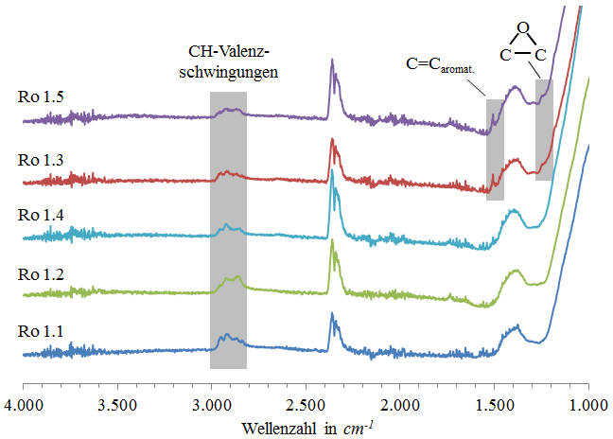
Figure 1: Example

Figures must be numbered with Arabic numerals. Figure captions should be in font size 9 pt. Please place captions on the left (e.g. Figure 1). For images, you can use the template Image and for captions the template Caption.

References
The heading of the references should not be numbered and shall otherwise be formatted as a chapter heading.
References are numbered consecutively, beginning with one, and placed in square brackets (both in the text and in the reference list at the end).
When referring to a reference item, please simply use the reference number, as in [2]. Do not use “Ref. [3]” or “Reference [3]” except at the beginning of a sentence, e.g. “Reference [3] shows …”. Multiple references are each numbered in separate brackets (e.g. [2], [3], [4]–[6]).
For the individual references please use the template References.
[1] Author, A.; Author, B.: Technical Contribution A. In: Author, C. et al: Reference Book for Applied Technologies, Ilmenau, D, 2001, pp. 15–25.
[2] Author, D. et al: Reference book ABC, Publishing house, Dresden, 2003, pp. 56–89.

first.author@contact.edu

